**Practical – 9**

**Aim:** To perform Frequency Shift Keying (FSK) Modulation and Demodulation

**Student Group Detail**

|  |  |  |
| --- | --- | --- |
| No | Enrollment No. | Student Name |
| 1 | 23162121027 | Dwij Desai |
| 2 | 23162121020 | Aagam shah |
| 3 | 23162121024 | Priyal soni |

**Block Diagram**

**1. Frequency Shift Keying (FSK) Modulation**

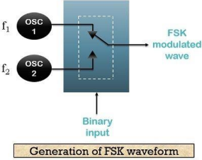

**2. Frequency Shift Keying (FSK) Demodulation**

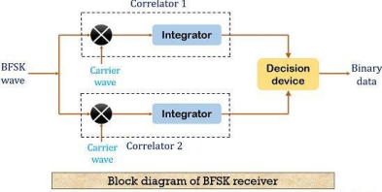

**Description:**

**Modulation**

In wireless transmission, wider communication bandwidth is almost always the key to better reception and signal recovery. Frequency modulation types can therefore show better performance on received signal quality. In digital data transmission, this corresponds to Frequency Shift Keying (FSK). FSK is a type of FM where the modulating signal assumes discrete values and shifts the output frequency to a set of predetermined discrete frequency values. If the information consists of only two values (binary), they are sometimes referred as the mark and space frequencies. An example binary information signal and FSK modulated signal are shown in the following figure.

In frequency shift keying, the signals transmitted for spaces (binary zeros) and marks (binary ones) are



respectively, where ��0 is an arbitrary initial phase. This is called a discontinuous phase FSK system, since the sinusoidal are generated independently and therefore the modulated signal is discontinuous at the switching times.

**Demodulation**

Demodulation of FSK signal can be done by converting FSK to ASK by a filter whose ascending/descending slope is centered between two FSK frequencies, followed by an ASK demodulator. Similar to synchronous demodulators, these two discrete frequencies can also be replicated at the receiver (via PLLs) and a synchronous demodulation can be performed.

**Expected Waveforms:**

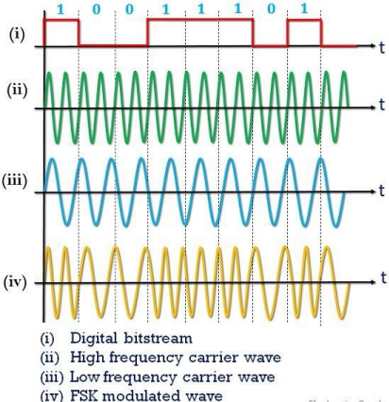

**Observations:**

**Circuit Diagram**

**Case 1**

∙ Data: 11001100(Aagam shah)

∙ Waveforms

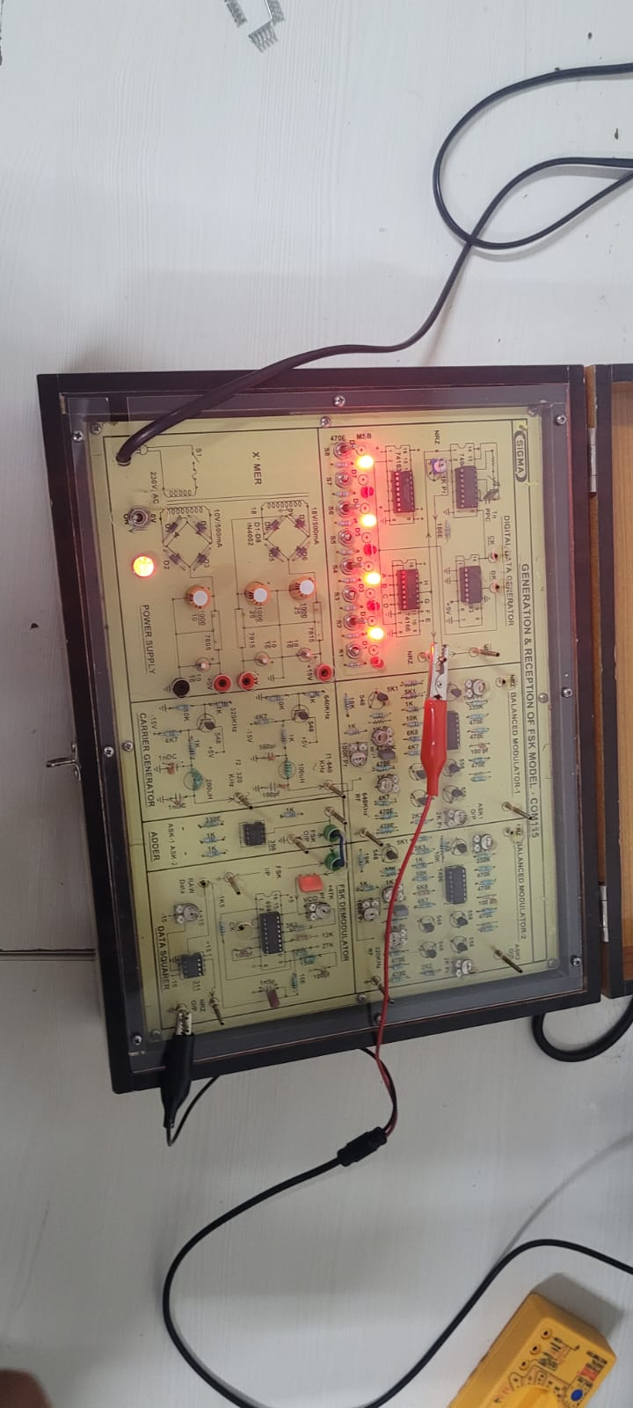

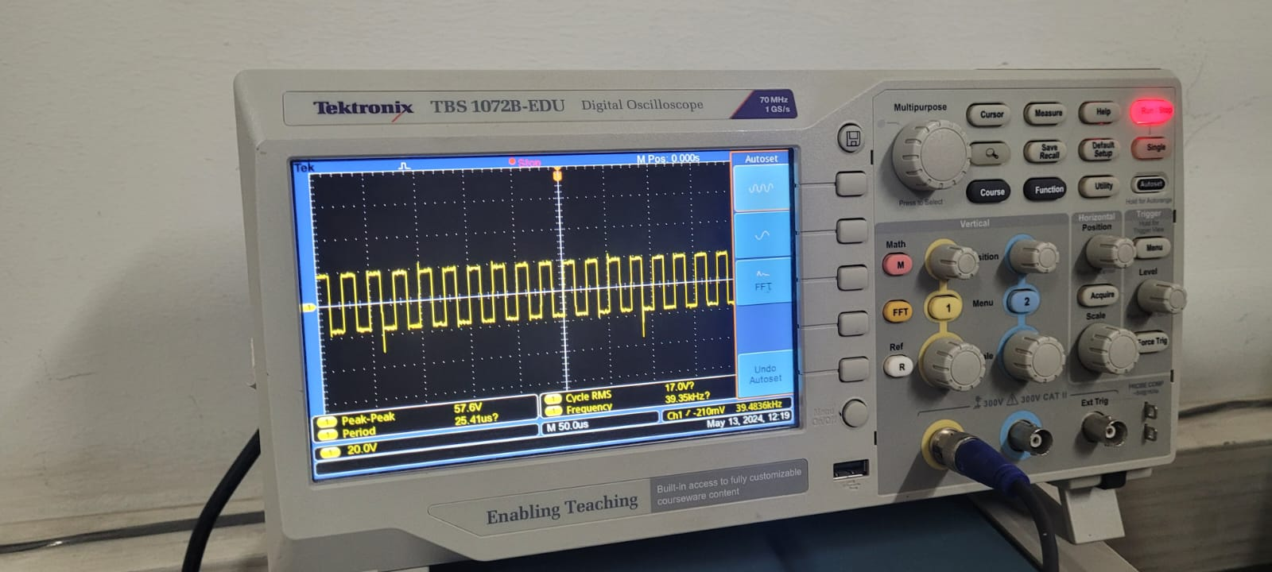

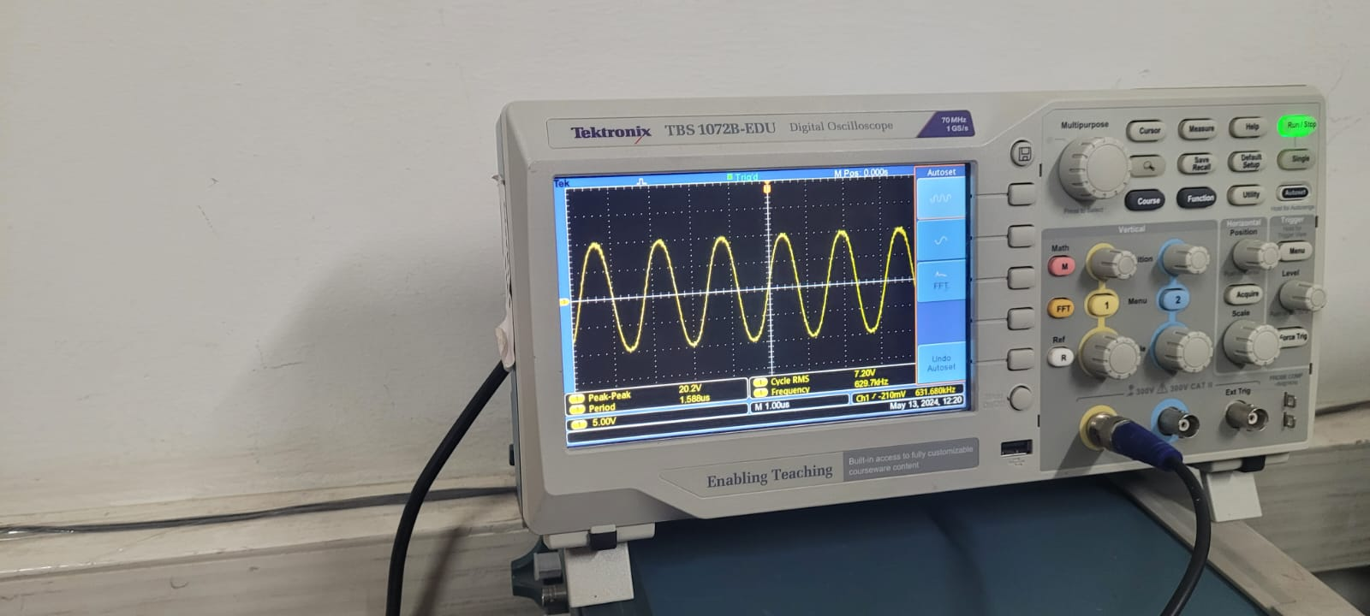

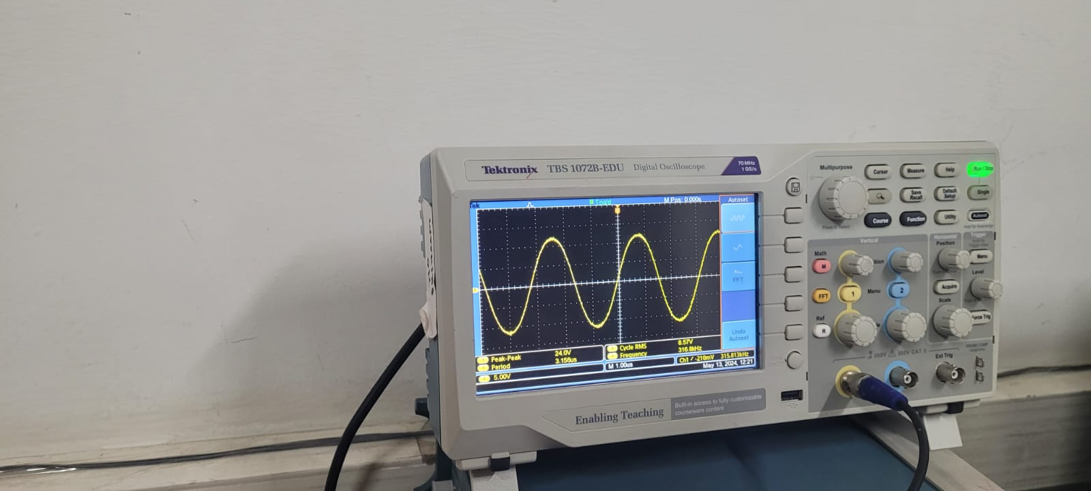

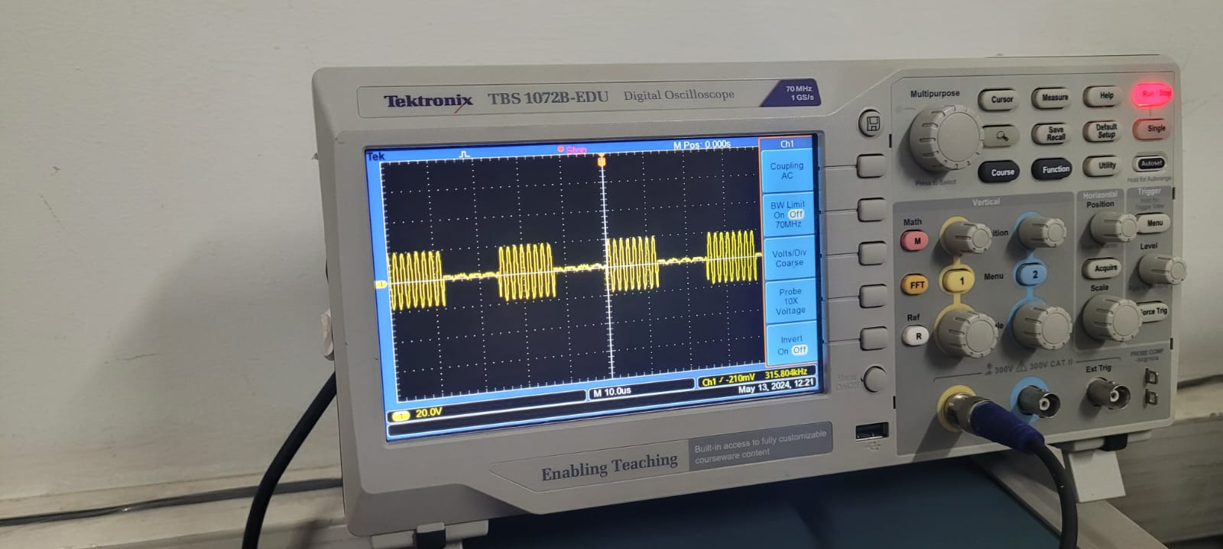

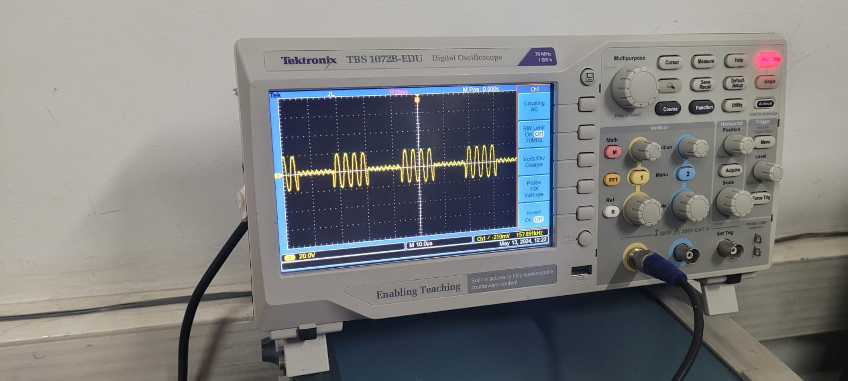

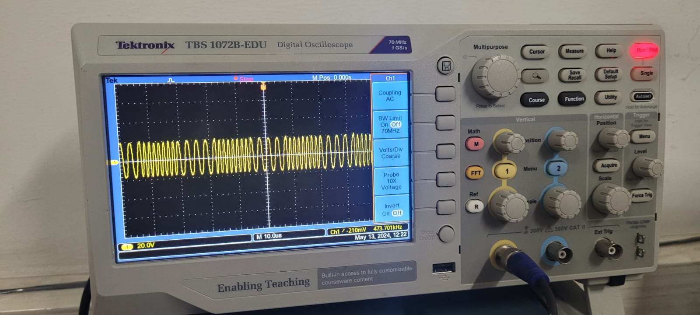

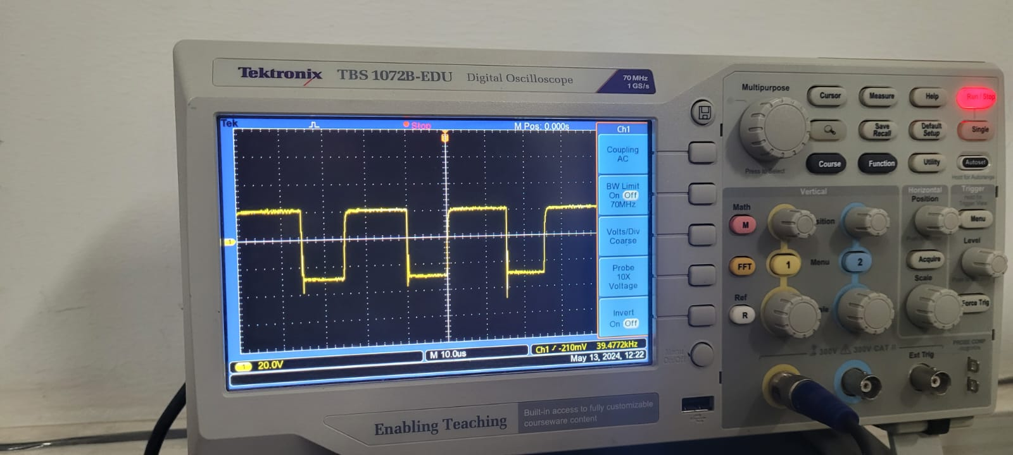

**Case 2**

∙ Data: 10101010(Dwij Desai)

∙ Waveforms

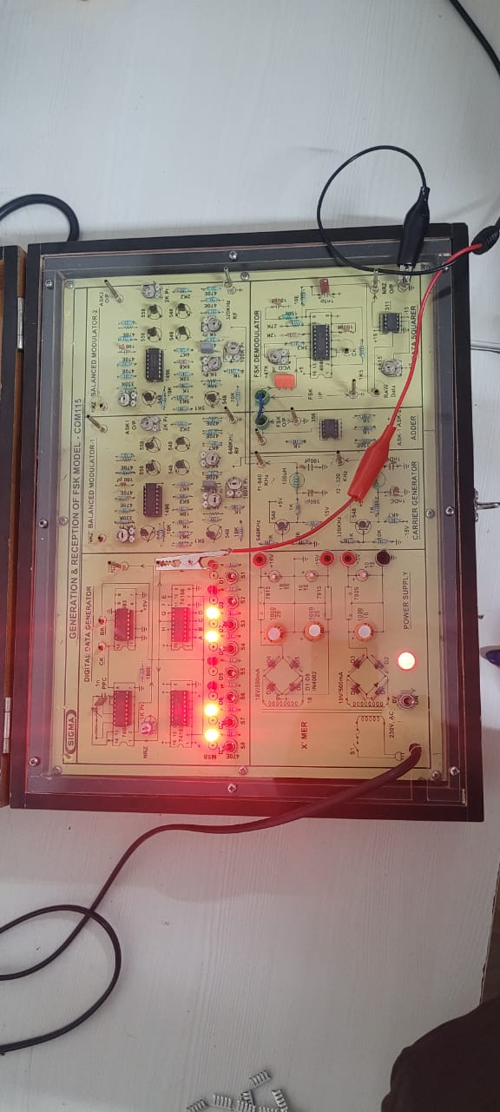

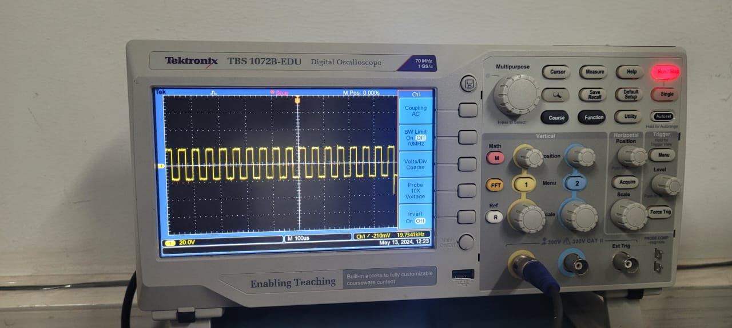

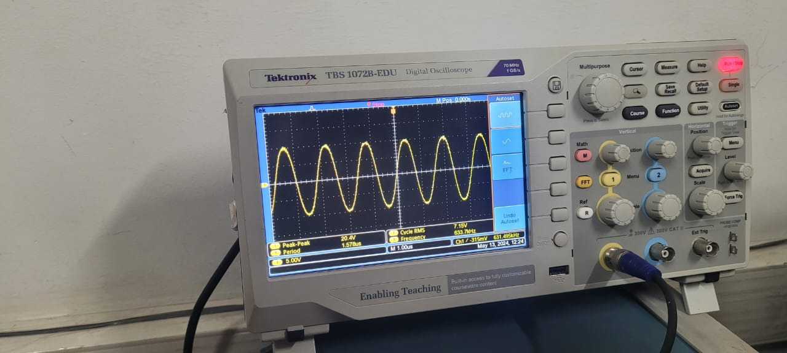

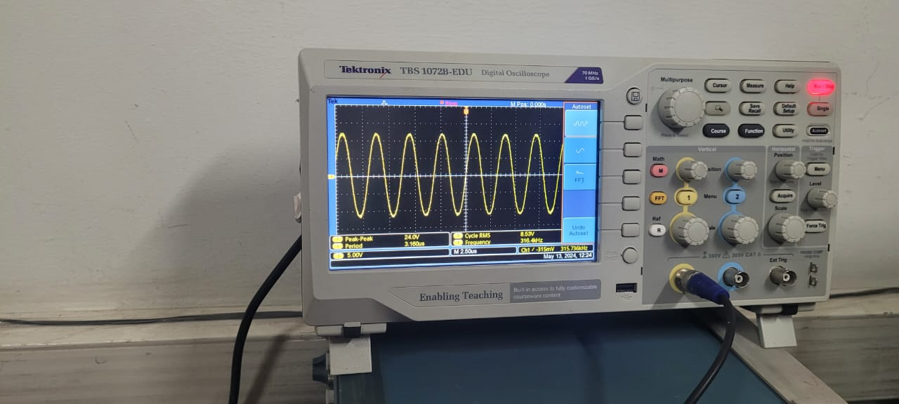

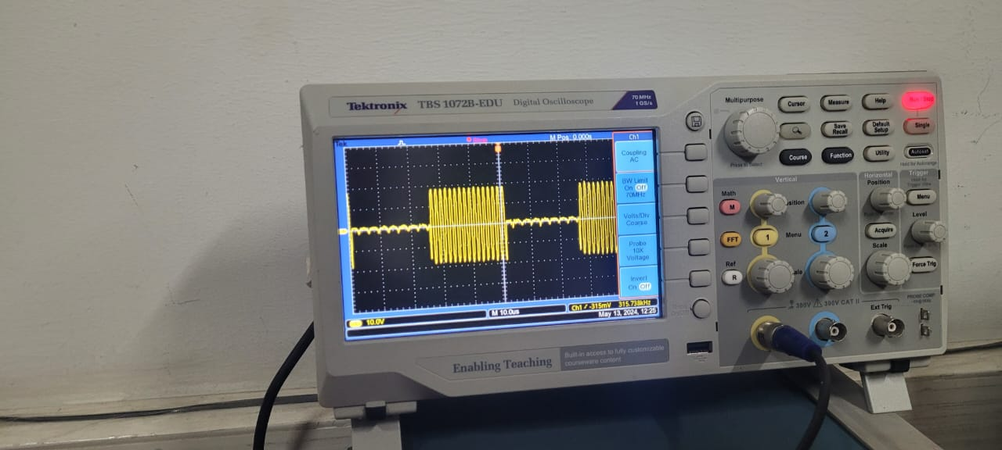

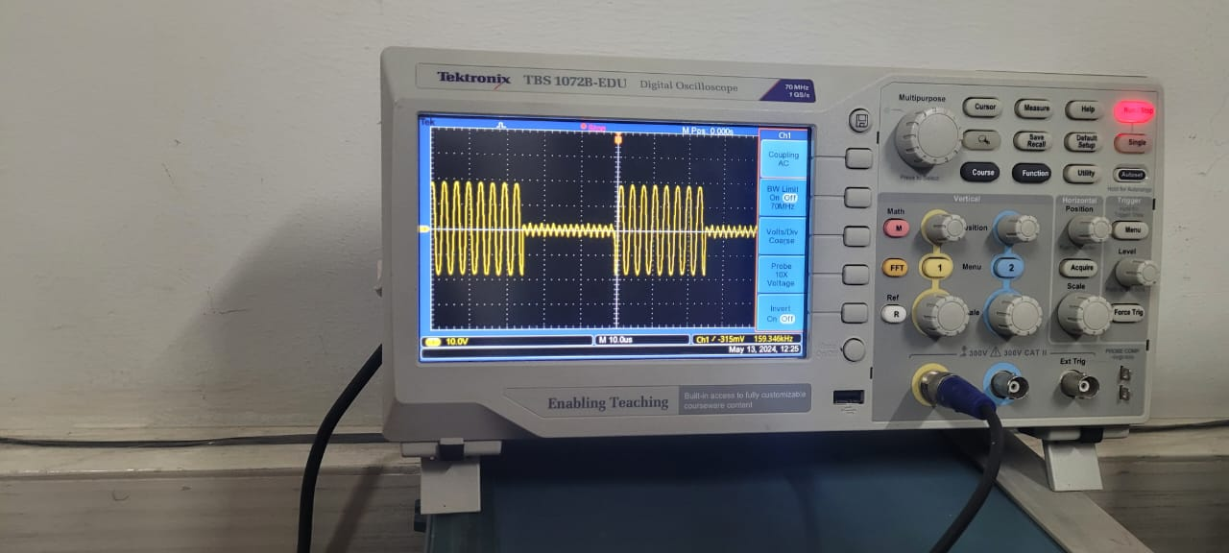

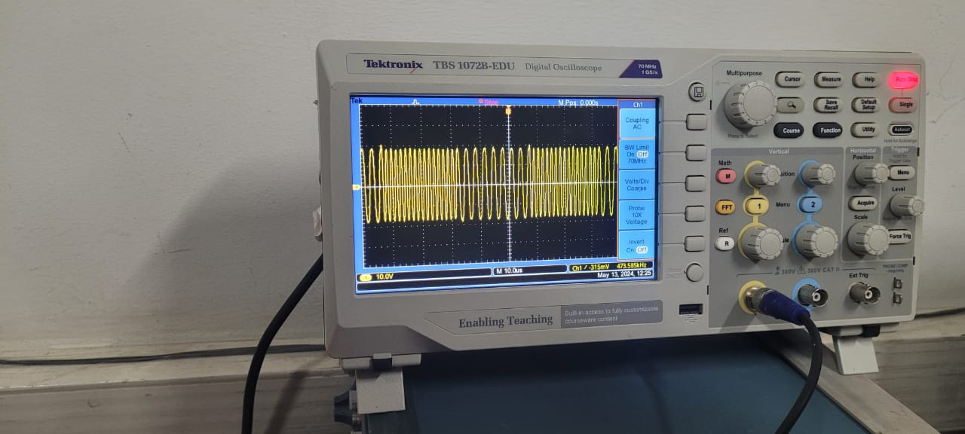

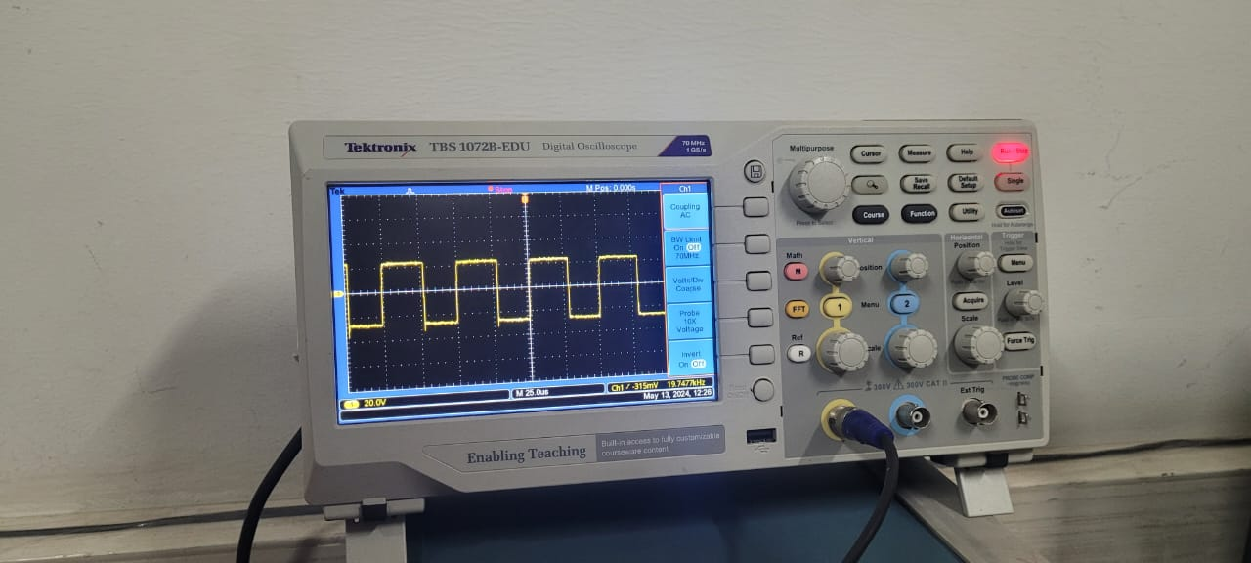

**Case 3**

∙ Data: 10110111(Priyal soni)

∙ Waveforms

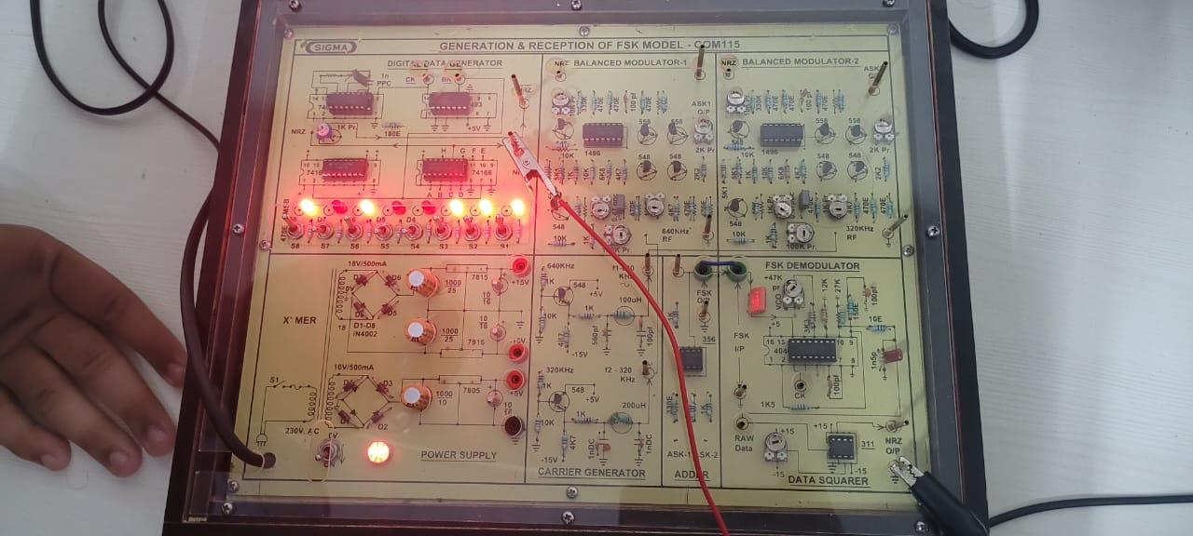

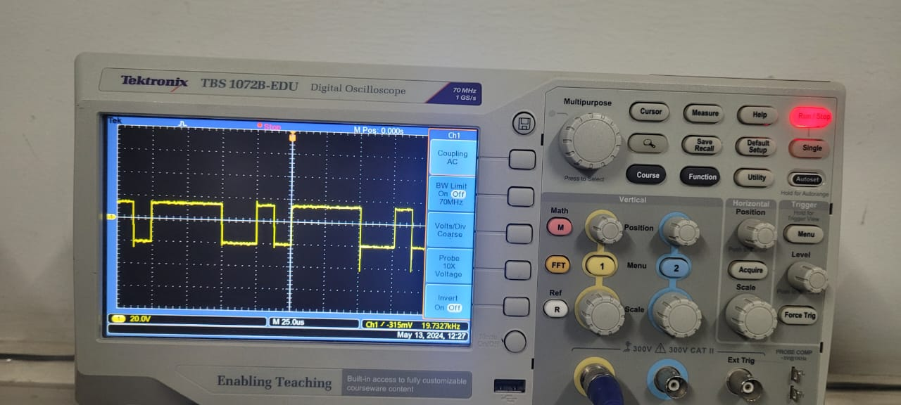

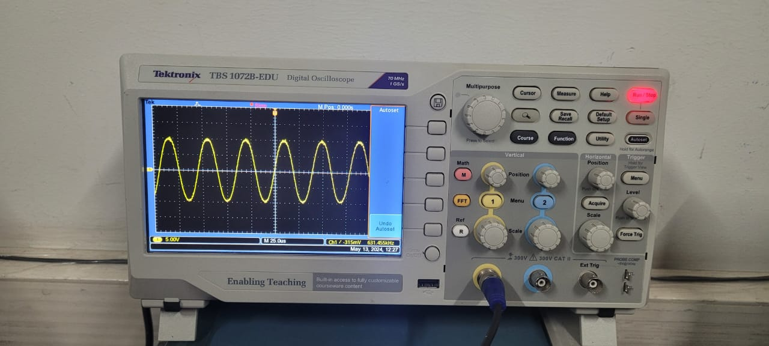

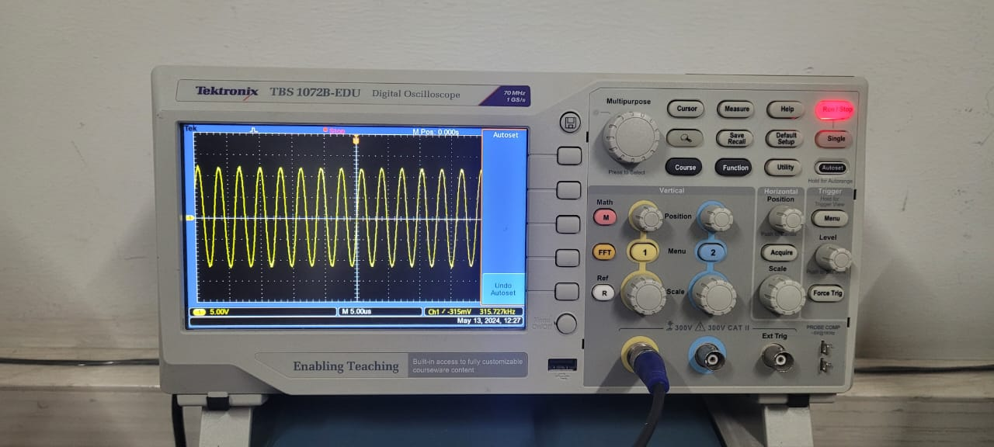

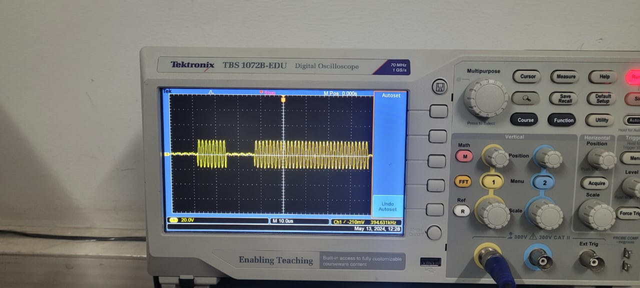

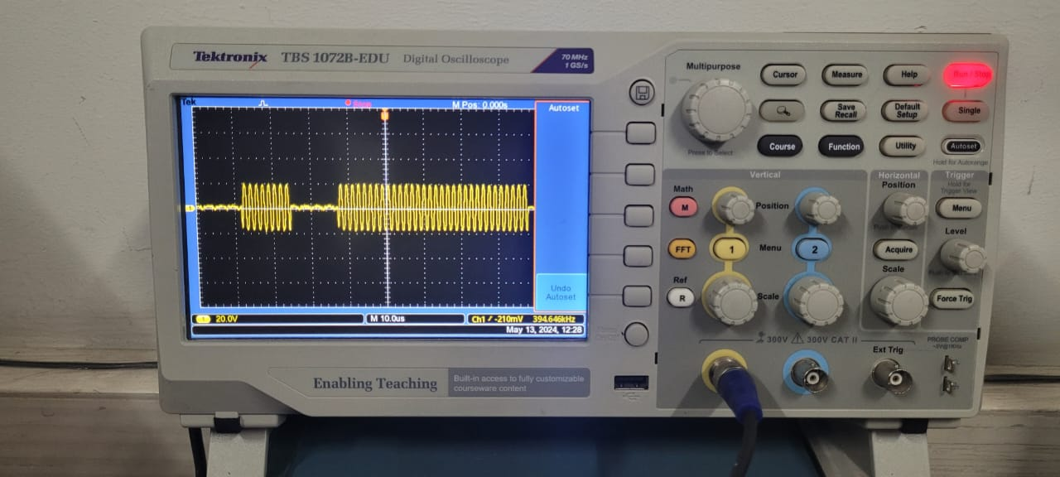

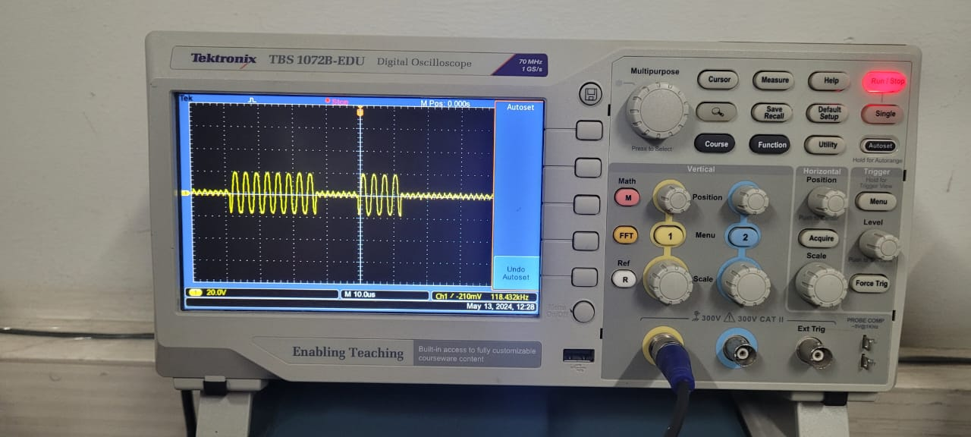

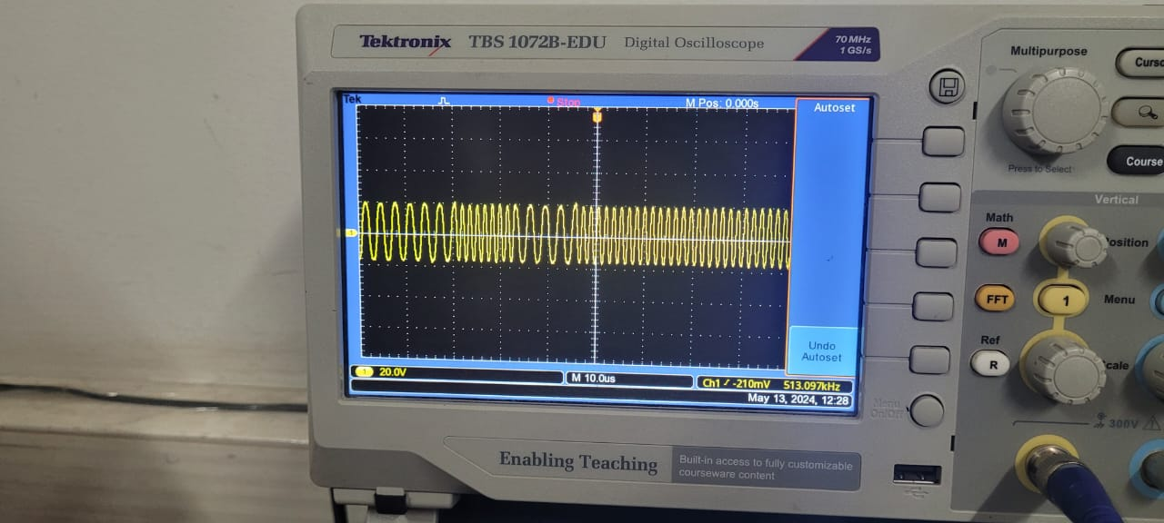

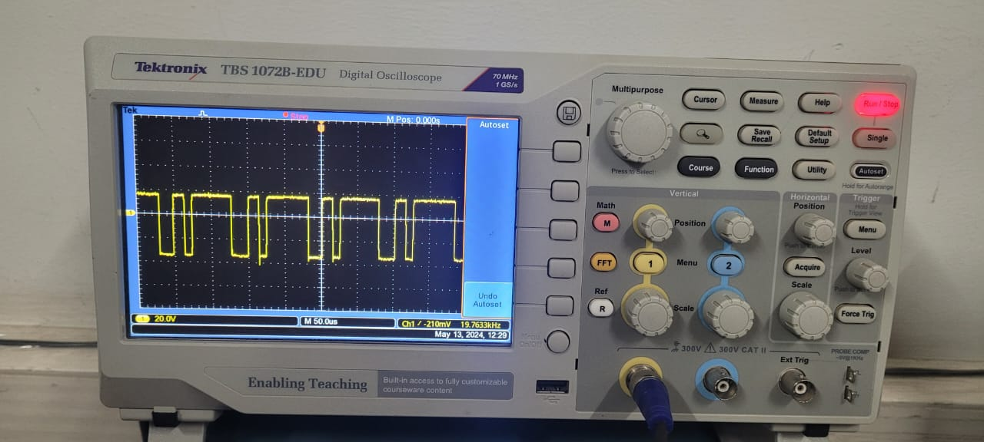

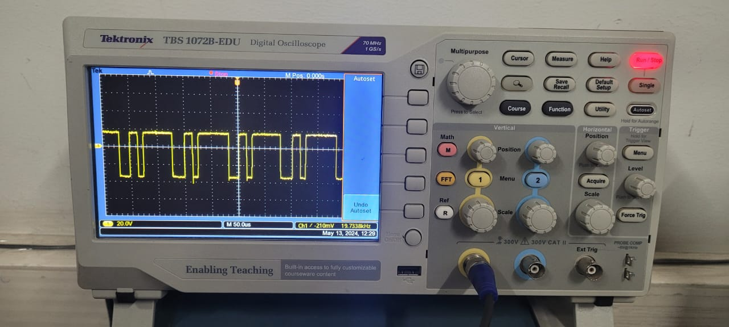

**Conclusion:**